**TravelTrex** **Tours**

1. **Introduction**:

**1.1. Overview**:

TravelTrax Tours, a tour operator, leverages Zoho Books to manage their bookings, track expenses, and handle invoicing for their customers. They can generate professional invoices, reconcile payments, and monitor their financial performance. Zoho Books helps them streamline their financial operations and enhance customer service.

**1.2.** **Purpose**:

Zoho Books is an online accounting application that takes care of the accounting needs of your business. You can record, audit and analyze all financial transactions easily. Watch this video to get a glimpse into the different modules available in Zoho Books.

**2** .  **Problem Definition & Design Thinking:**

**2.****1.Empathy Map:**

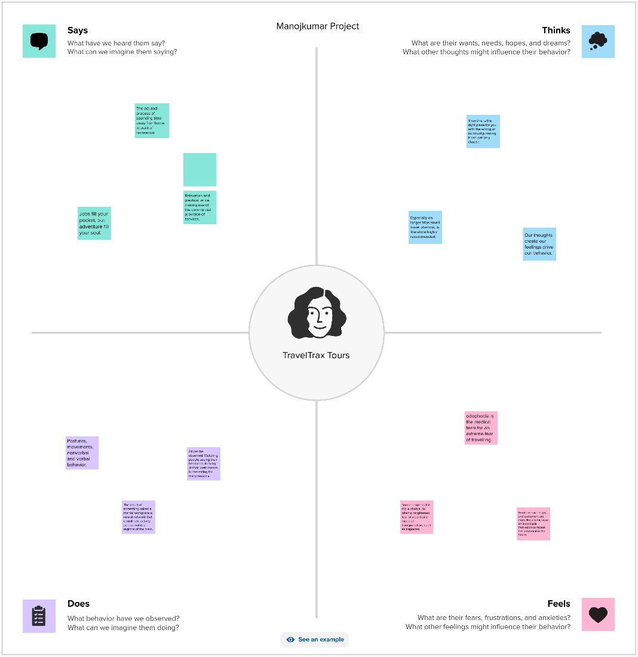

**2. Ideation & Brainstorming Map:**

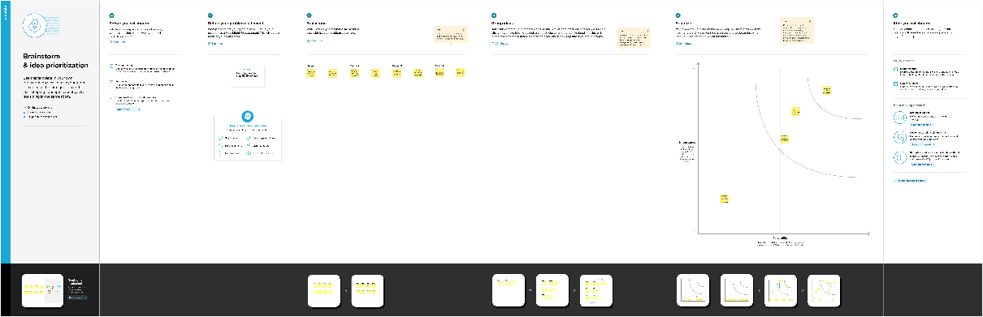

**3. Result**

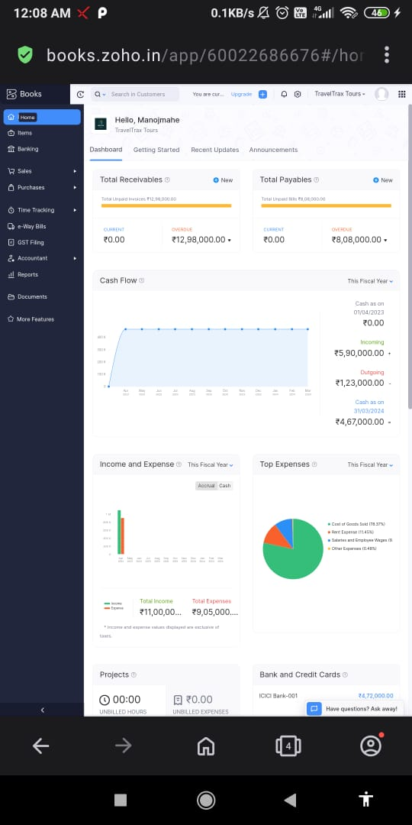

**4. Advandage & Disadvantage**

**4.****1.Advantage:**

Zoho Books Accounting Software offers incredible features to enhance your business. From fundamental invoicing and billing to tax calculations and project management, Zoho’s Best Accounting Software encompasses an essential tool for your accounting and finance data. Also, it enables you to manage clients, reconcile bank accounts, and generate insightful financial reports that assist you in growing business smoothly.

**4.2. Disadvantage:**

While Zoho Books has excellent accounting features and automation abilities, we found a few drawbacks.

Monthly transaction cap.Multiple subscriptions for multiple businesses.Additional users require a fee.Fewer integrations than competitors.No payroll services.Accounts payable limitation.

**5.Application**

Zoho Creator is a low-code app development platform (LCAP) with drag-and drop capabilities and a visual app-building approach that empowers citizen developers. Zoho Creator is a low-code application development platform that helps you design, develop and run any business software you need.

**6.Scope**

Zoho CRM APIs use selected scopes, which control the type of resource that the client application can access. Tokens are usually created with various scopes to ensure improved security. For example, you can generate a scope to create or view a lead, or to view metadata and so on.

**7.Conclusion**

Conclusion. Zoho One is a wide-ranging ecosystem of tools for all departments that enables seamless collaboration, ensuring the overall growth of your organization. You get a mobile version for every application that will help you to access information across devices.